

Project Report on
“CARBON FOOTPRINT CALCULATOR”
B.TecH
(Branch – CSE in Cyber Security and Digital Forensics)

Submitted By:
NEIL RATNA VARSHNEY

ACKNOWLEDGEMENT

This Project report was completed as a result of support from many people, although not all of them can be mentioned.

We wish to express our sincere gratitude to God for his protection, providence, guidance and above all, for sustaining us.

We are greatly indebted to our good supervisor Teacher’s Name for his useful and necessary observation, suggestions, contribution and corrections. We would not have been able to achieve anything in this research without your supervision. May God enrich you greatly in every area of life.

Finally, we wish to express our appreciation to our parents for their love and support.

NEIL RATNA VARSHENY

Introduction

In an era defined by growing environmental consciousness, understanding and mitigating our impact on the planet has become paramount. Our Carbon Footprint is a measure of the total greenhouse gas (GHG) emissions caused directly and indirectly by an individual, organization, event, or product. These gases—primarily carbon dioxide (CO2), but also methane, nitrous oxide, and fluorinated gases—are the leading drivers of climate change.
The Carbon Footprint Calculator is an essential tool designed to demystify this complex environmental metric and translate abstract concepts into actionable data. It provides a quantitative assessment of your personal or organizational contribution to global warming by analyzing emissions generated across key sectors such as:
- Transportation: Flights, driving, and public transit.
- Home Energy Use: Electricity, heating, and cooling.
- Diet and Consumption: Waste generation and purchasing habits.
Why is this calculator important?
- Awareness and Education: It highlights which activities in your life have the greatest environmental cost.
- Actionable Insights: It provides a baseline measurement, which is the crucial first step toward setting reduction goals and making sustainable lifestyle choices.
- Accountability: It empowers individuals and organizations to take responsibility for their emissions and contribute to global climate efforts.
By using this calculator, you are moving beyond general concern and engaging in a meaningful way with the challenge of sustainability, paving the way for a more environmentally responsible future.

Abstract

This document introduces the Carbon Footprint Calculator, a user-friendly and scientifically grounded tool designed to quantify the total greenhouse gas (GHG) emissions attributable to a user's activities. The calculator provides a comprehensive assessment by analyzing input data across key emission sectors, including transportation (air, road, and public transit), residential energy consumption (electricity and heating), and consumption habits (diet and waste). Utilizing established emission factors based on national and international standards, the tool translates usage data into a single, standardized metric, typically measured in tonnes of carbon dioxide equivalent (tCO2).

The primary objective of the Carbon Footprint Calculator is to foster environmental awareness and drive behavioral change by providing individuals and organizations with an accurate, personalized baseline of their environmental impact. Beyond measurement, the calculator offers tailored suggestions and actionable steps for emissions reduction, facilitating the creation of personalized sustainability strategies. This critical tool serves as an initial and ongoing step towards mitigating climate change by empowering users to track progress, set reduction goals, and contribute effectively to global decarbonization efforts.

AIM of this project

Primary Aim: Empowering Climate Action
Key Objectives of the Project
These objectives break down the overall aim into concrete, measurable steps:
1. Measure and Quantify Environmental Impact
- Objective: To accurately calculate the total Greenhouse Gas (GHG) emissions (measured in tCO2, or tonnes of Carbon Dioxide equivalent) resulting from a user's activities, based on internationally recognized emission factors and methodologies (e.g., the GHG Protocol).
- Function: Collecting data on key areas like electricity use, fuel consumption, travel, and waste, and translating that data into a reliable footprint figure.
2. Inform and Raise Awareness
- Objective: To clearly illustrate the sources of the user's highest emissions and compare their footprint to regional or global averages, thereby increasing environmental literacy.
- Function: Providing clear visualizations (charts, graphs) and easy-to-digest reports that highlight the impact of daily choices (e.g., air travel vs. reducing meat consumption).
3. Drive Behavioral Change and Mitigation
- Objective: To provide personalized, actionable recommendations and strategies that users can implement to effectively reduce their measured carbon footprint.
- Function: Offering concrete tips (e.g., switch to a renewable energy supplier, use public transport, reduce food waste) and often facilitating the setting of reduction goals and the tracking of progress over time.
In essence, the calculator serves as the diagnostic tool necessary to move from general concern about the environment to specific, measurable, and impactful actions.
Main Purpose
This purpose can be broken down into three key functions:
1. Measurement and Quantification
The most direct purpose is to calculate and express an individual's or organization's total contribution to global warming.
- It gathers data on activities like energy use, transportation, and consumption.
- It then converts this data into a standardized metric, typically tonnes of carbon dioxide equivalent (tCO2) per year, using scientifically established emission factors.
- This provides a crucial baseline figure that defines the scope of the user's environmental impact.
2. Awareness and Education
The calculator serves as a powerful educational tool that raises environmental literacy
- It helps users understand which specific activities (e.g., air travel, beef consumption, home heating) are the largest sources of their emissions.
- By comparing a user's footprint to national or global averages, it contextualizes their impact and demonstrates the necessity for change.
- It moves the climate change discussion from abstract concepts to concrete, relevant numbers
3. Driving Action and Mitigation
Ultimately, the purpose is to motivate and guide effective reduction strategies.⁹
- It uses the measured data to provide personalized, actionable recommendations for reducing emissions.
- It allows users to set goals and track their progress over time, turning the abstract goal of "being more sustainable" into a series of monitorable steps.

Conclusion

The Carbon Footprint Calculator serves as a powerful and essential tool at the intersection of individual action and global climate strategy. Its successful implementation moves beyond simple data collection to create a tangible link between daily human activity and the consequential impacts on the planet's climate.
The calculator is not the final solution to climate change, but rather the critical first step in any effective sustainability journey. It establishes a necessary baseline, provides the motivation for change, and acts as a continuous tracking mechanism.
Moving forward, the power of this tool lies in its scalability and integration. By promoting widespread use and integrating with broader sustainability frameworks (like carbon offsetting or community reduction projects), the Carbon Footprint Calculator can collectively drive the systemic shifts required to transition toward a low-carbon, resilient global society.

Output

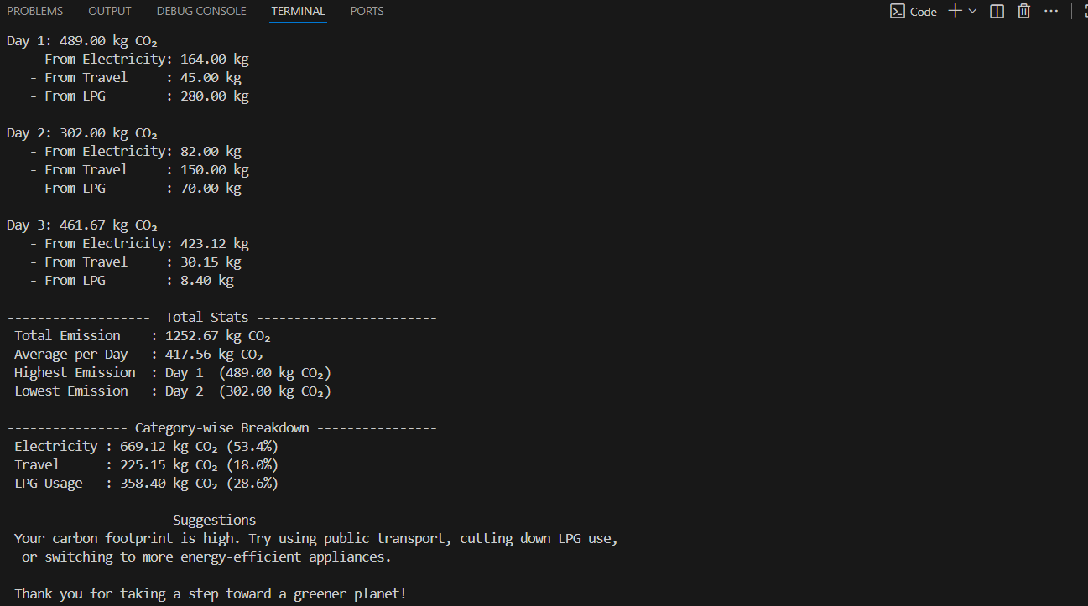

Reference

1. Code for Interview YouTube Channel (https://www.youtube.com/playlist?list=PL5BFcXE899zxVrWaO3Ul6ly2SVJMnJFOr)

2. Learning MYSQL, JavaScript, jQuery, PHP, HTML, CSS3,
Website: http://www.w3schools.com

3. PHP and MySQL video tutorials
Website: http://www.freehinditutorial.com, http://www.youtube.com

4. Veneeva, V. (2006), “E-Banking (Online Banking) and Its Role in Today's Society”,
Ezine articles

5. JavaScript validation for empty input field
Website:http://stackoverflow.com/questions/3937513/javascript-validation-for-empty-
input-field ,

6. JavaScript form validation: Validate Password, Validate Email, Validate Phone
Number, http://webcheatsheet.com/javascript/form_validation.php

